LOAD BALANCER

- Configure Classic Load balancer
While creating an EC2 instance, we should use these scripts
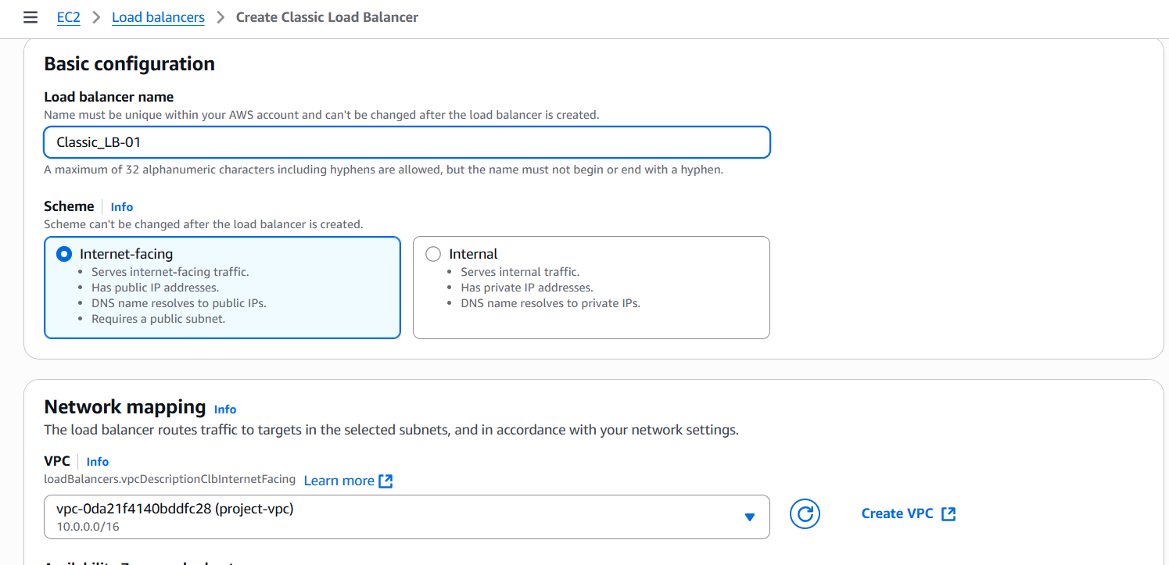
Create vpc
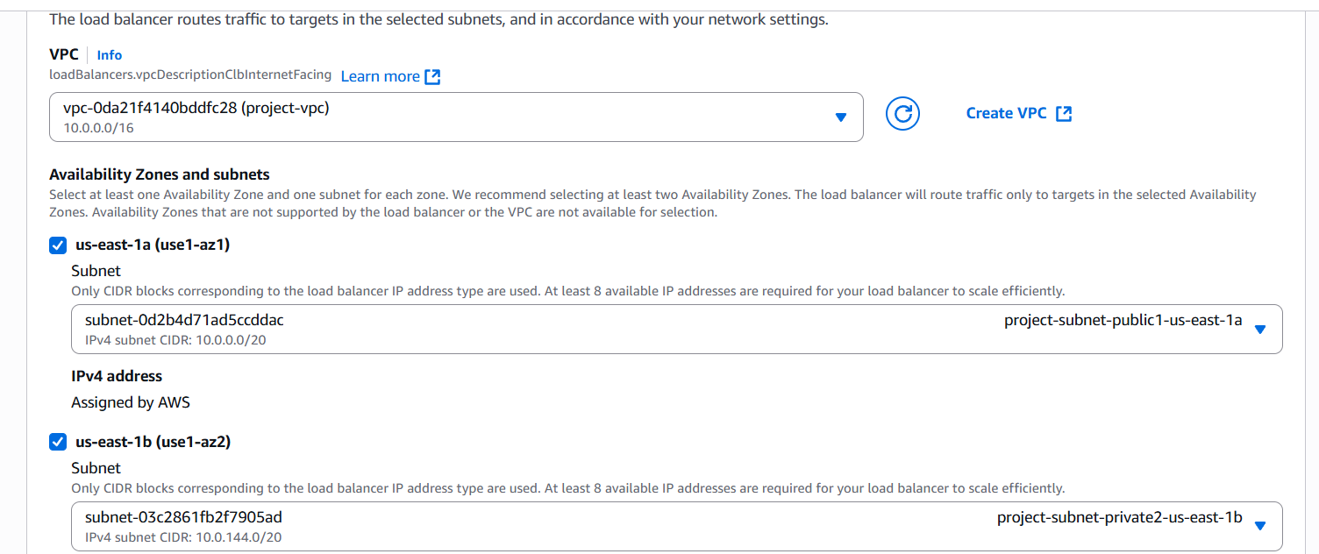

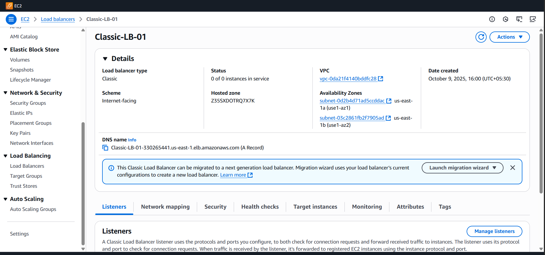

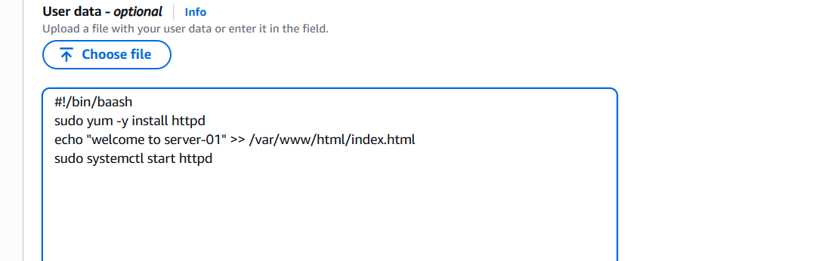
Prerequisites
- EC2 instances already running in the same Region & VPC you’ll use for the load balancer.
- Public subnets in each AZ you want the CLB to be in (for internet-facing).
- IAM/Console access (or aws CLI configured with credentials and correct region).
- Security group(s) created for the load balancer and for the backend instances (we’ll detail rules below).
(See AWS getting-started notes for CLB creation.) AWS Documentation
Console: Step-by-step (easiest)
- Sign in to the AWS Management Console → EC2 → left nav Load Balancers. Click Create Load Balancer. Expand Classic Load Balancer → Create. AWS Documentation
- Basic configuration
  - Name: give a unique name (letters/numbers/hyphens).
  - Scheme: internet-facing (public) or internal.
  - VPC: pick the VPC where your instances live.
- Listeners: Add listener(s) such as:
  - HTTP: Load Balancer Port 80 → Instance Port 80 (Protocol HTTP).
  - HTTPS: Load Balancer Port 443 → Instance Port 443 (or 80 if you want SSL termination at the CLB). If using HTTPS, you’ll choose a certificate (ACM or IAM) in the next step. AWS Documentation+1
- Availability Zones / Subnets: select the public subnets (one per AZ you want nodes in).
- Security groups: attach a security group for the CLB (allow inbound on listener ports from client CIDR e.g. 0.0.0.0/0 for public sites). See recommended rules below. AWS Documentation
- Health check: set Ping Protocol (HTTP/HTTPS/TCP), Ping Port, Ping Path (e.g. /health), Interval, Timeout, Healthy/Unhealthy thresholds. (Defaults are usually fine; pick a path that returns HTTP 200.) AWS Documentation
- Register instances: select the EC2 instances you want the CLB to route to. AWS Documentation
- Review & Create → Create load balancer. After creation, open the load balancer and check the Description tab for the DNS name (e.g. my-clb-1234567890.region.elb.amazonaws.com) and check the Instances/Target instances tab for health status.

- Configure Application Load balancer.
I created two EC2 Instances
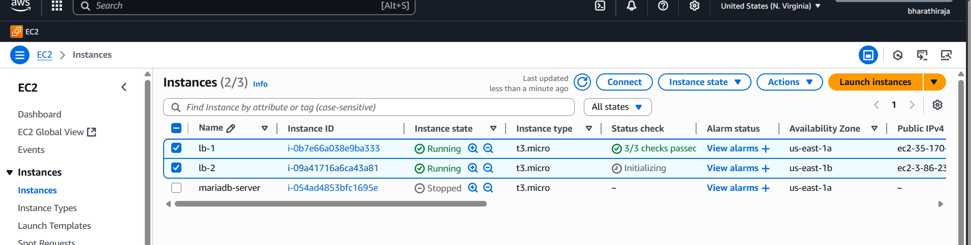
Create an application Load Balancer

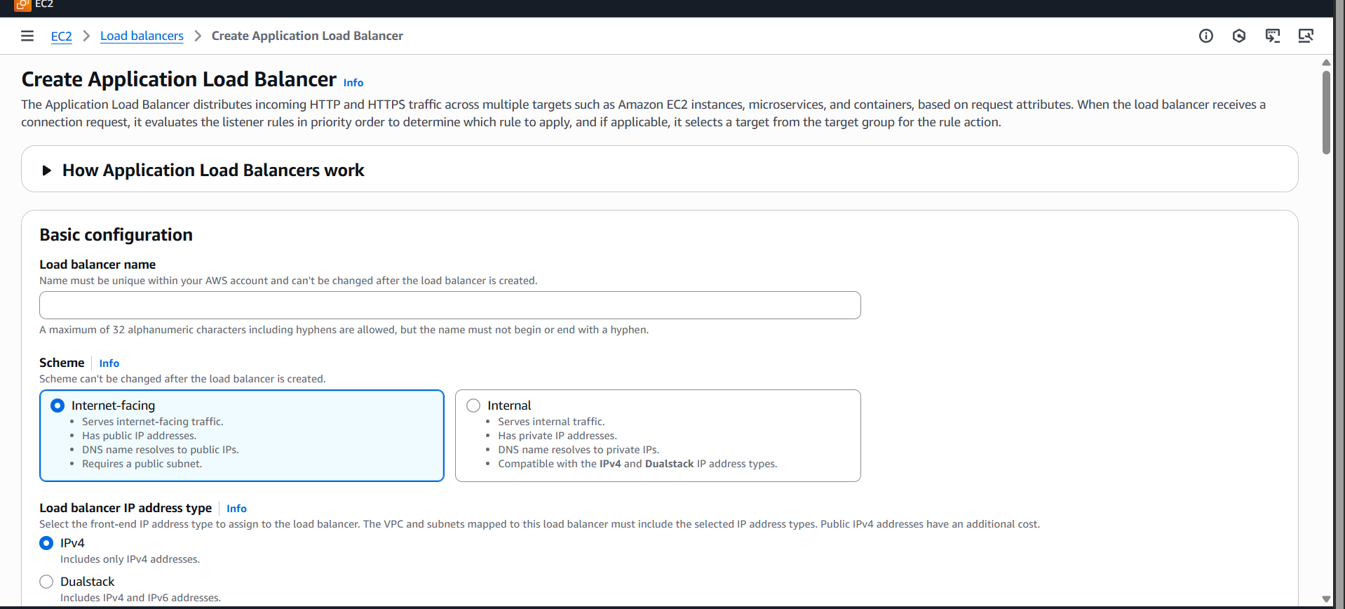
Choice availability zones and sub net
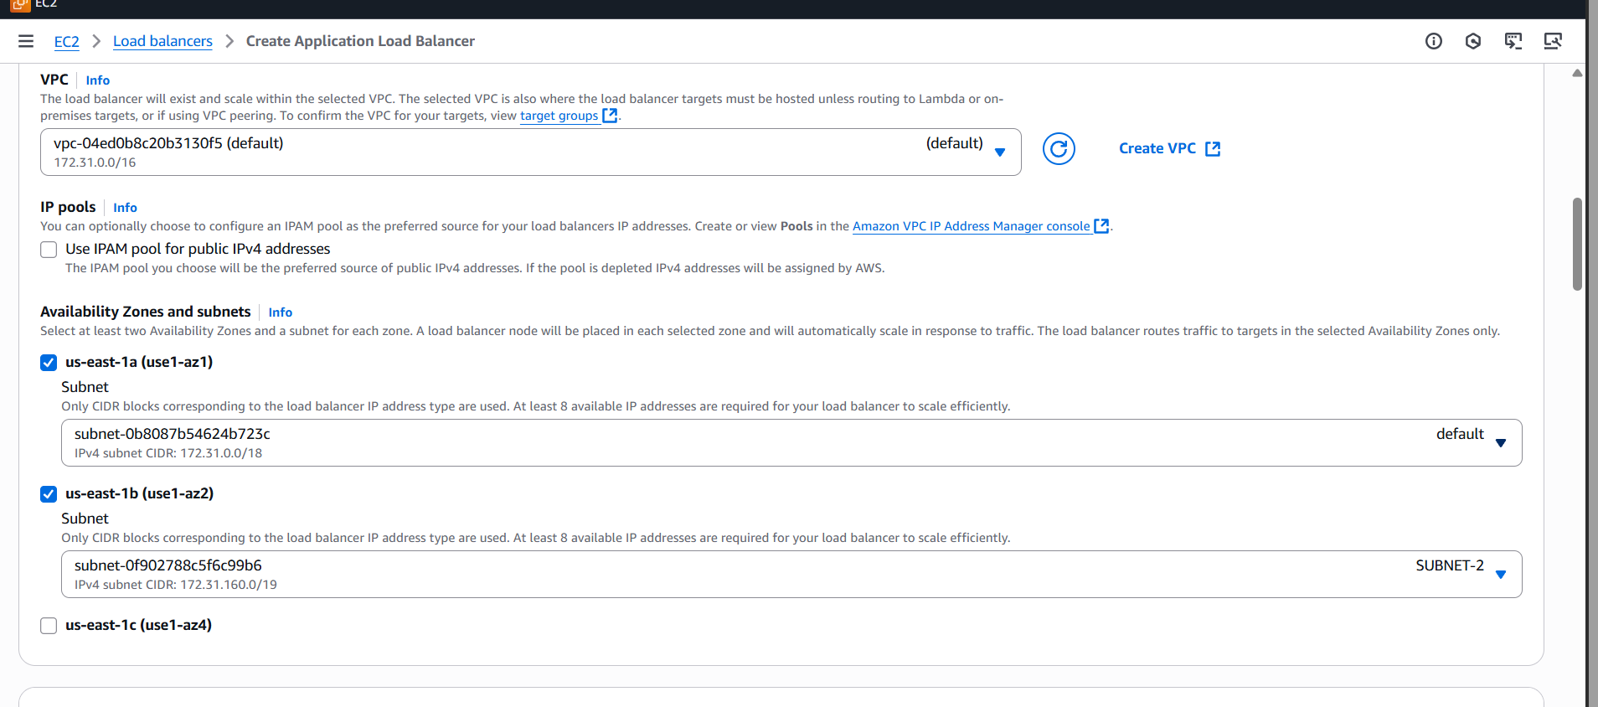
Application load balancer opened
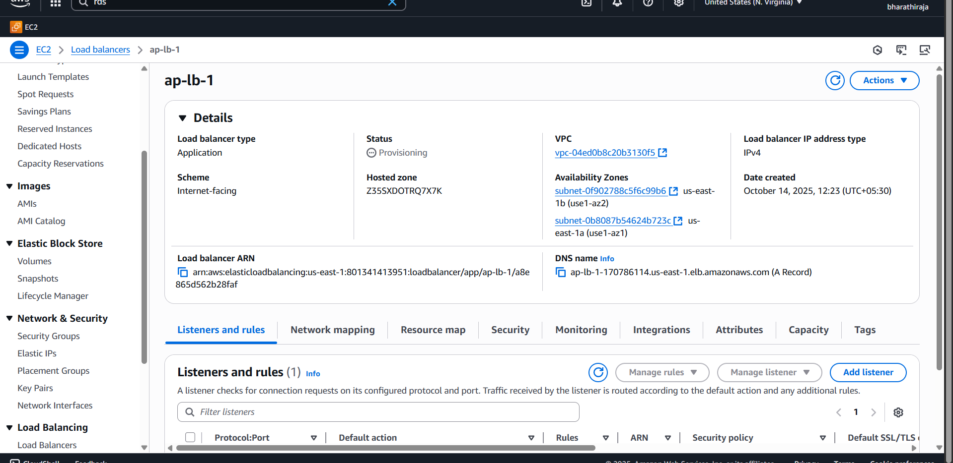
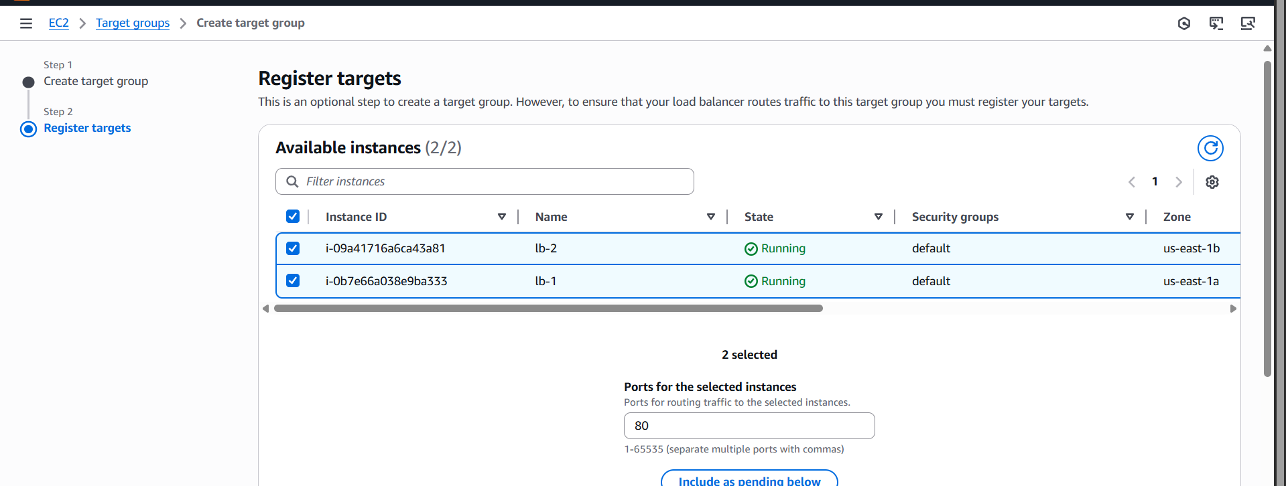
Target group open successfully 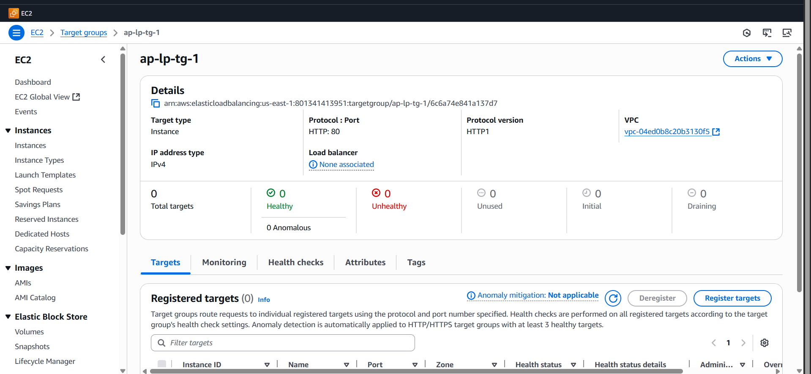
THERE is a link copy and paste it you can get it result
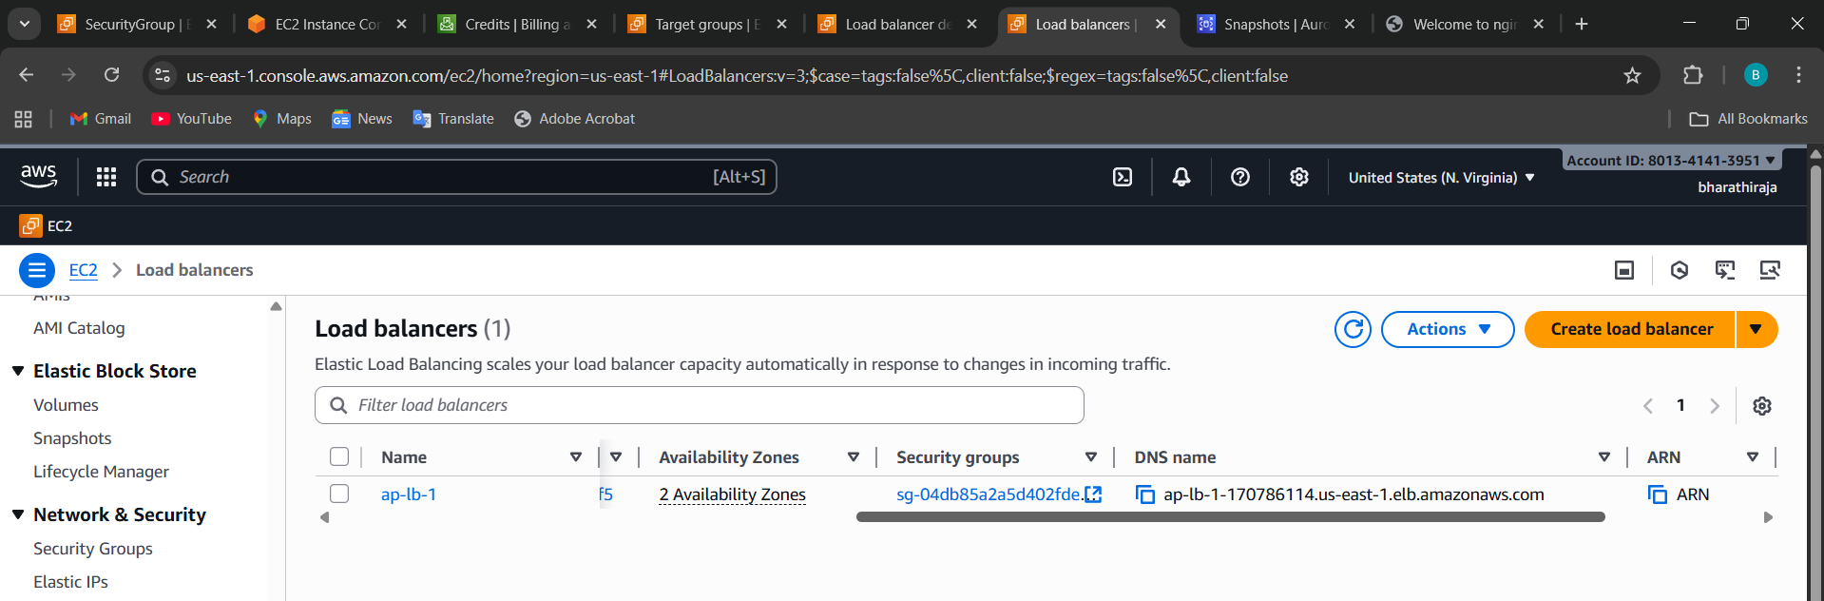
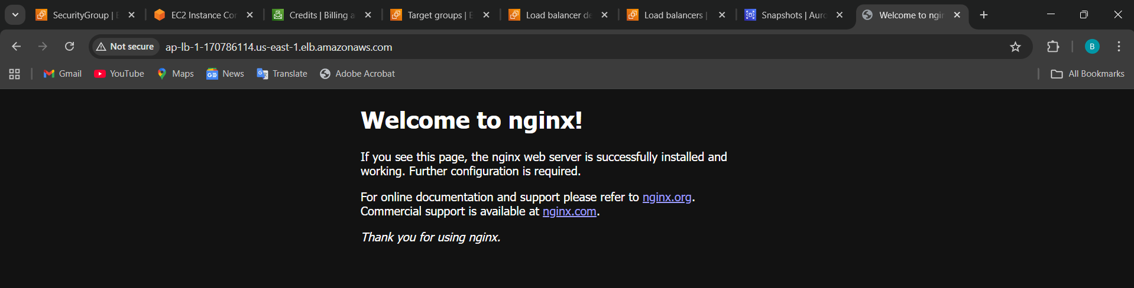

What the Target Group handles:
Function | Description
🎯 Routing destination | Defines where (which EC2s or IPs) the traffic goes
🔍 Health checks | ALB periodically checks if the targets are healthy
🔄 Load distribution | ALB balances traffic evenly across healthy targets
🧭 Path-based routing | You can have multiple target groups for different paths
⚡ Auto scaling integration | New instances in an Auto Scaling Group auto-register in the target group

Meanwhile, it will ask the Target group to create a tg
Create a Target Group (Console)qw
- Console → EC2 → left menu → Target Groups → Create target group.
- Type: Instances (or IP or Lambda depending on use).
Component | Role
ALB (Application Load Balancer) | Accepts user requests (entry point)
Listener | Defines protocol/port and rules
Target Group | Defines where the traffic goes (EC2/IP/Lambda)
Target | Actual EC2 instance or backend

- Configure Network Load balancer.

Quick overview — why choose NLB?
- Operates at Layer 4 (TCP/UDP/TLS) for very low latency and high throughput.
- Preserves source/client IP (so backends see real client IP). AWS Documentation+1
- Can provide a static IP per AZ (and you can attach Elastic IPs). AWS Documentation
- Supports TCP, TLS, UDP, TCP_UDP target group protocols and large port ranges

Pre-checklist (before you start)
- VPC with subnets in 2+ AZs (recommended).
- EC2 instances or IP targets running your service and listening on the desired port.
- Security groups that allow traffic from the NLB (for instance target SG should allow app port traffic from NLB).
- If you need a fixed public IP, have Elastic IPs ready (optional).
- AWS CLI configured (if you’ll use CLI).

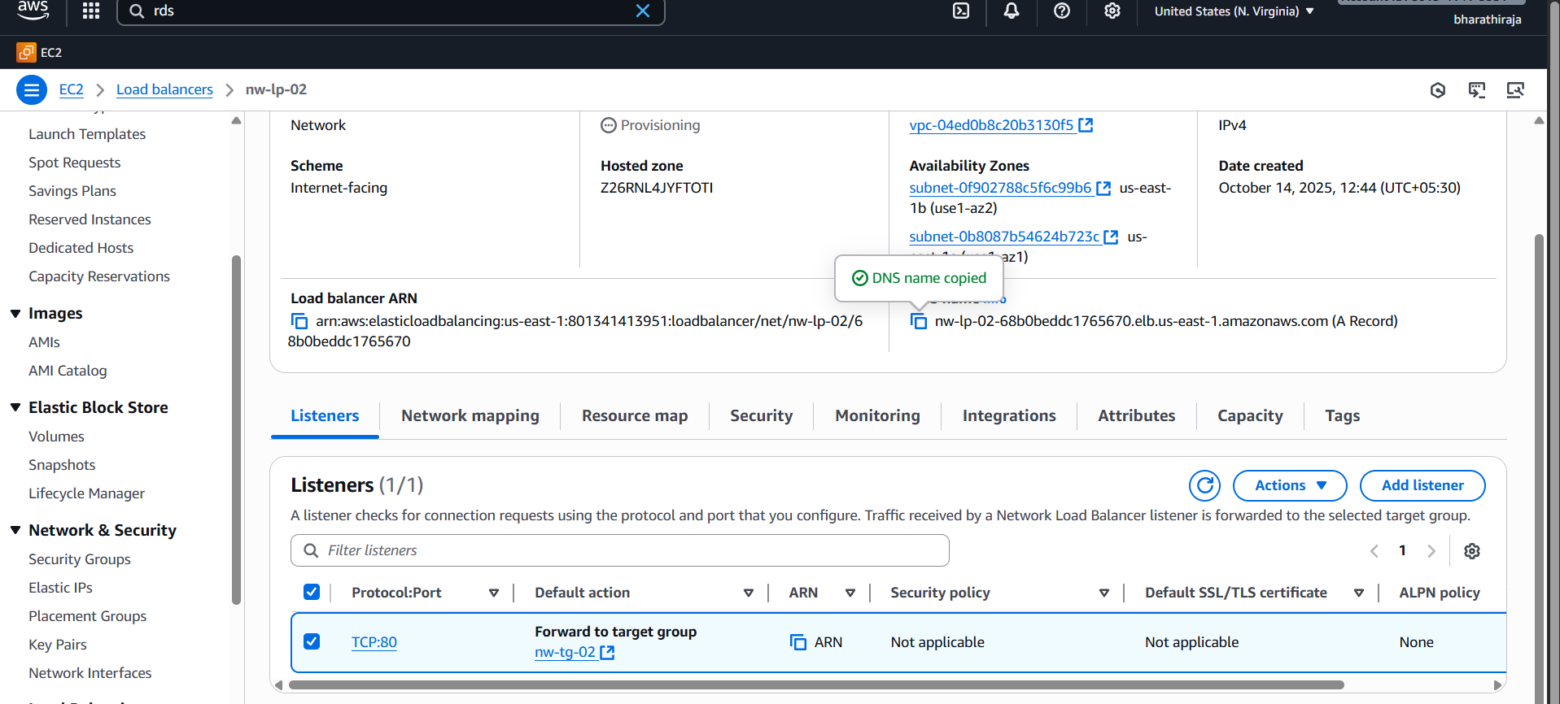
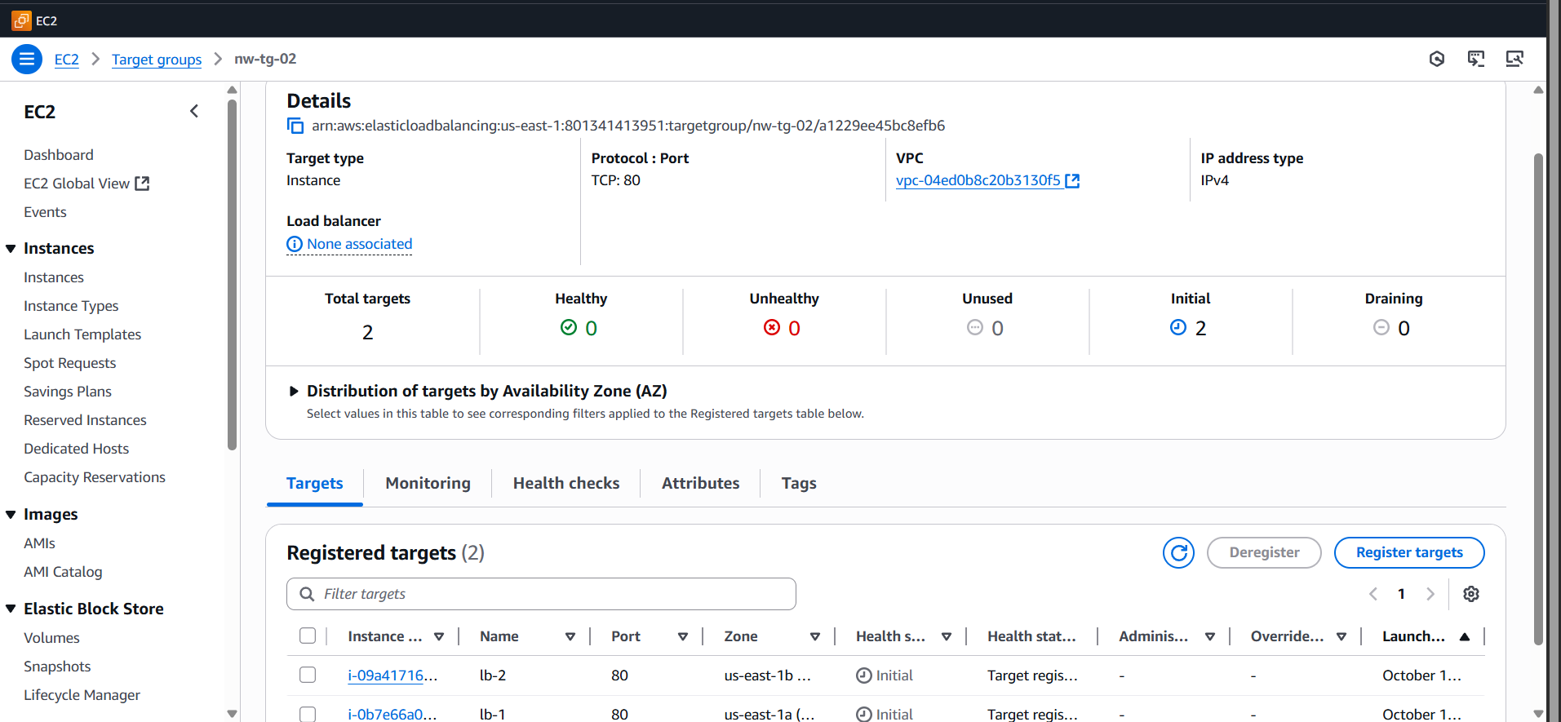
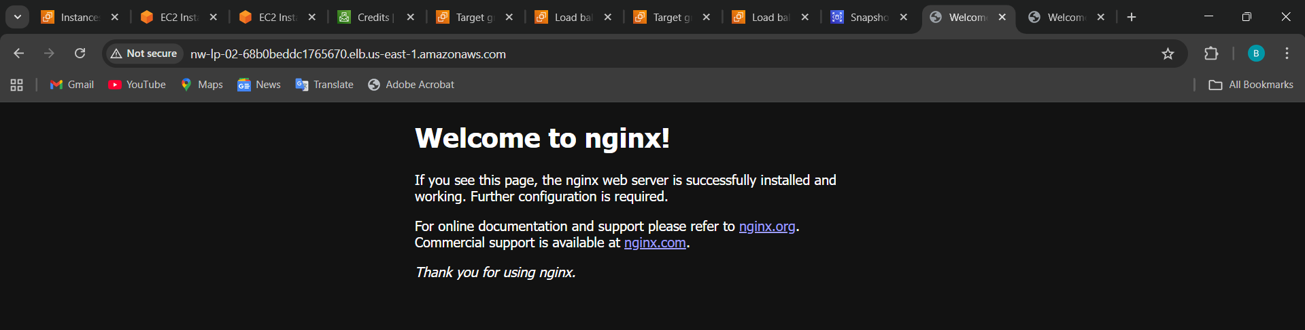

- Attach SSL for the application load balancer
High-level flow
- Obtain certificate (ACM request or import).
- Add an HTTPS listener (443) to the ALB and attach a certificate.
- Optionally add HTTP (80) listener that redirects to HTTPS.
- Adjust security groups, test, and enable access logs/renewal monitoring.

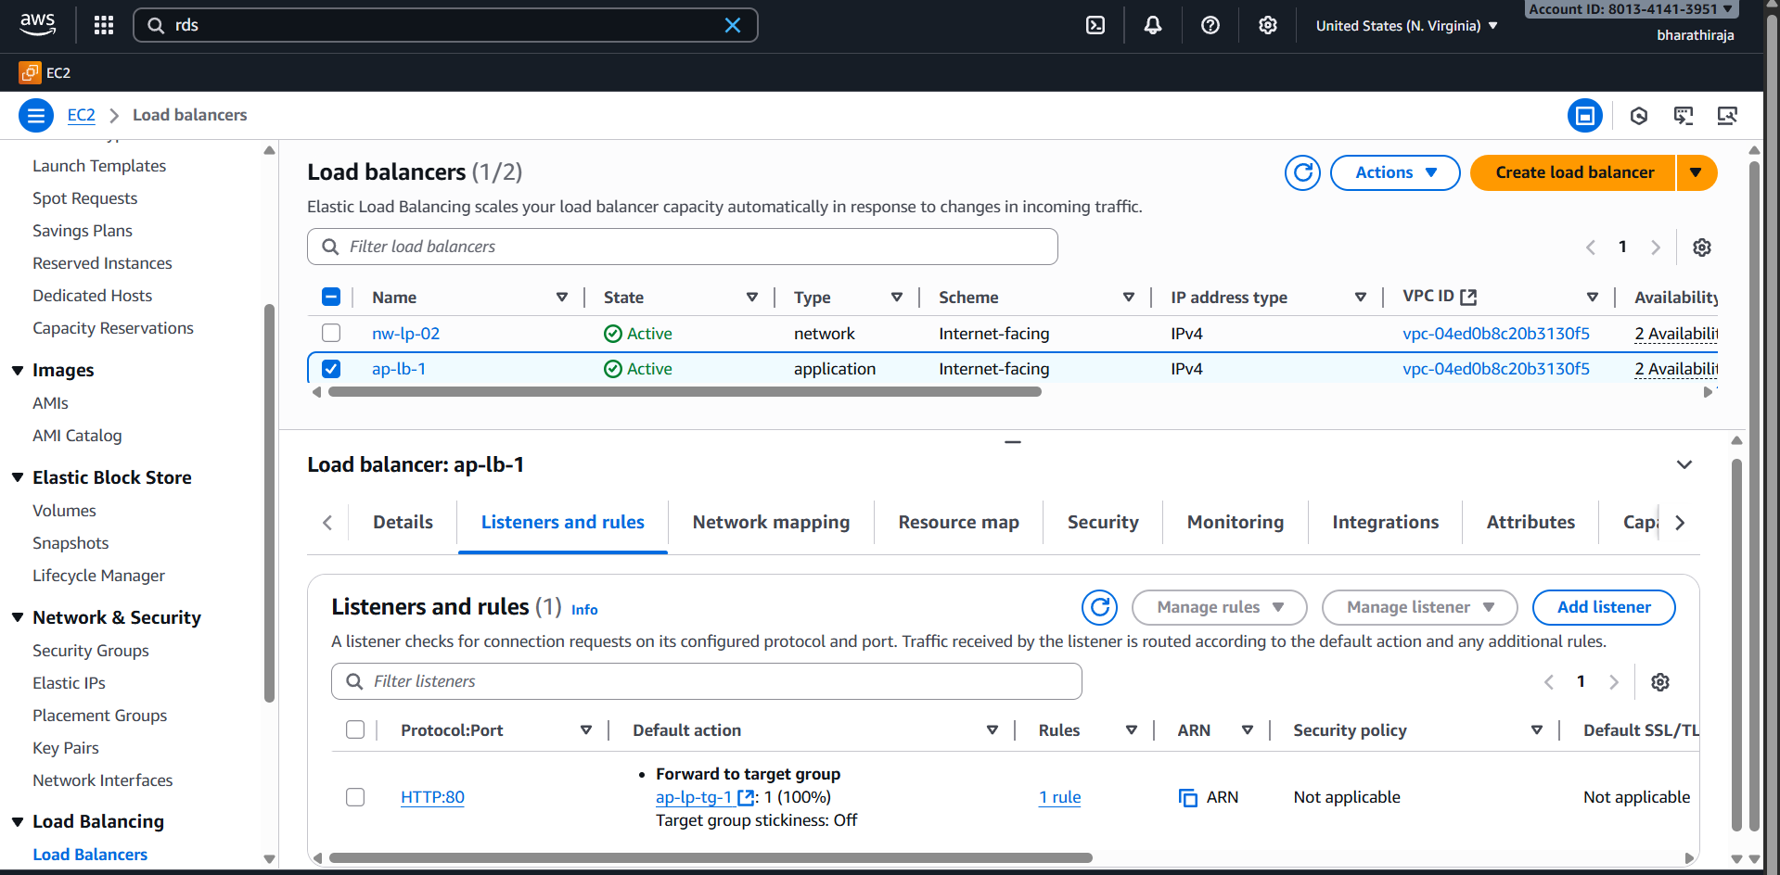
Select and go to inside add a listener
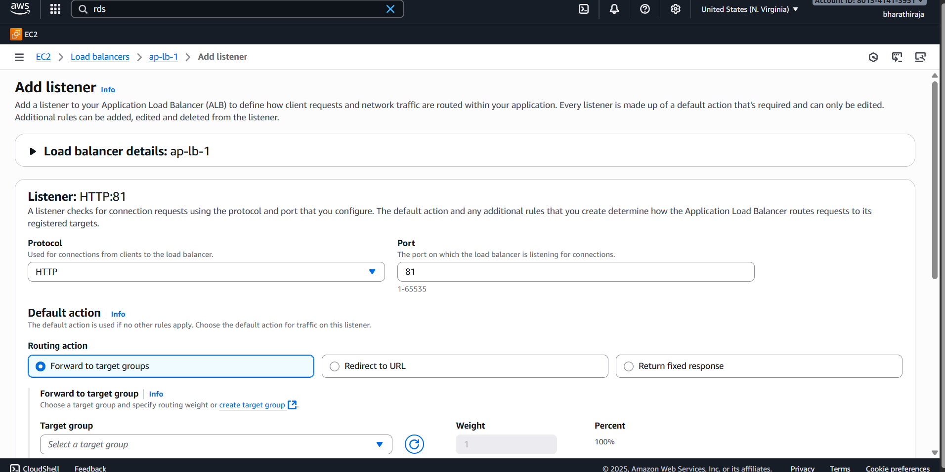
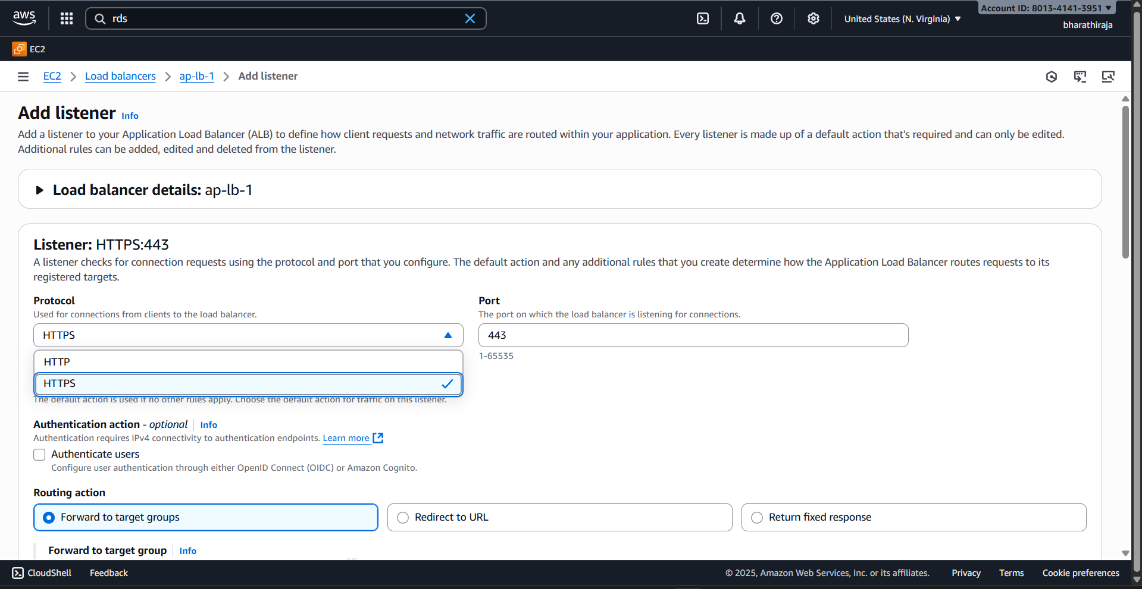
I got certificate
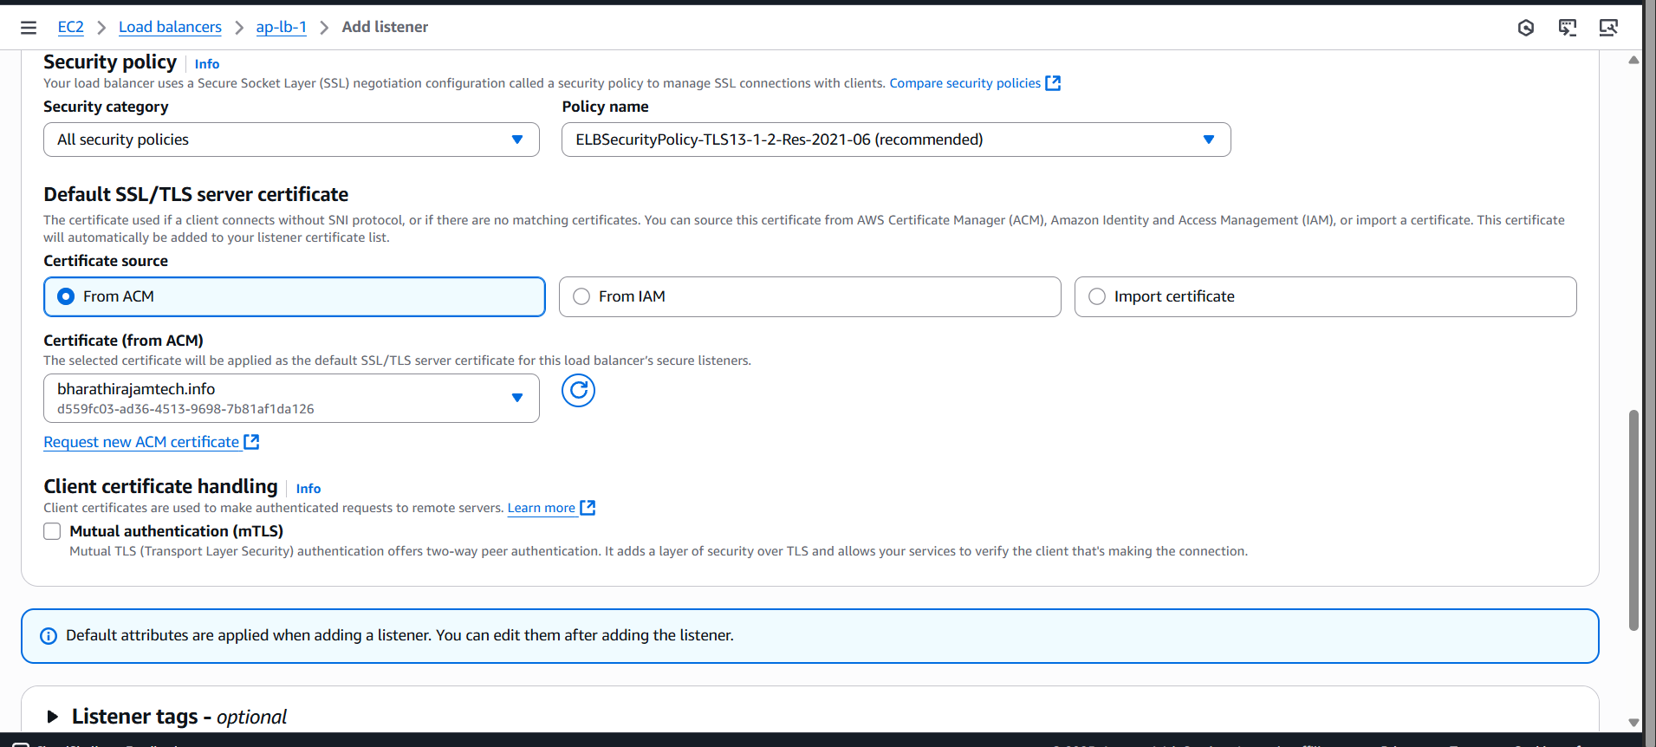
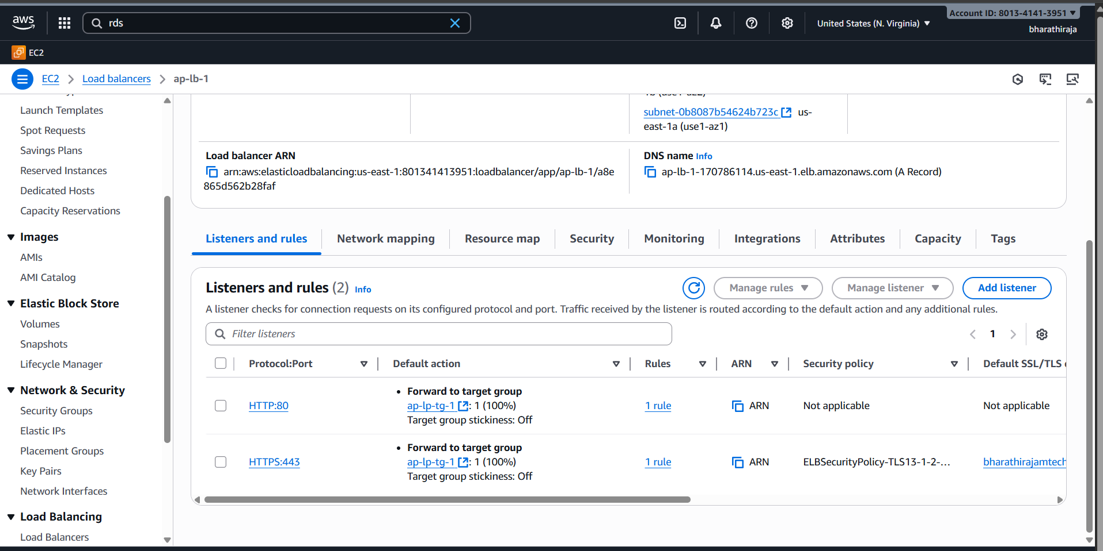

- Map Application load balancer to R53
Follow these steps
1 | Verify the hosted zone exists in Route 53
2 | Copy ALB DNS name
3 | Open Route 53 → Hosted zone → Create record
4 | Create Alias A record pointing to ALB
5 | Optional: Create CNAME for subdomains
6 | Test domain access
7 | Optional: Redirect www → root domain

Step 1: Ensure prerequisites
Before you start:
- You have a hosted zone in Route 53 for your domain (e.g., example.com).
- Your ALB is already created and active (status = Deployed).
- Your domain DNS is pointing to Route 53 (for root/apex domain or subdomain).
Find your ALB DNS name
- Go to EC2 Console → Load Balancers → Select your ALB
- In the Description tab, copy the DNS name, e.g.:

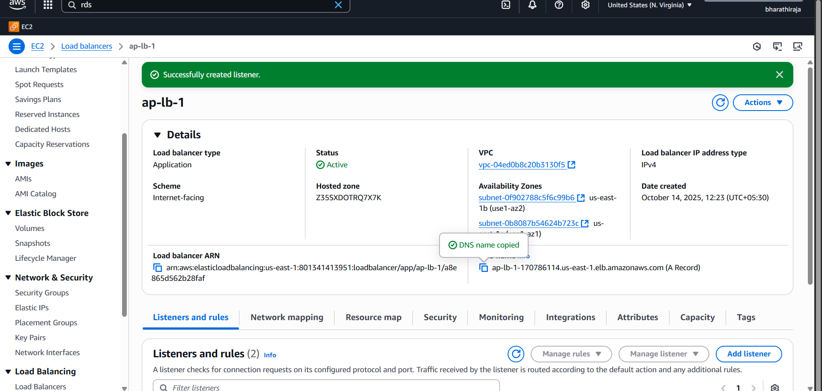
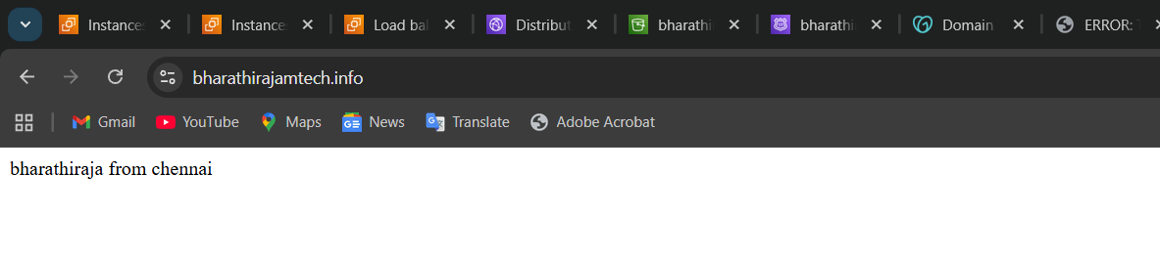
Step 3: Open Route 53 hosted zone
- Go to Route 53 → Hosted zones → select your domain
- You’ll see a list of existing records
Create an ALIAS record
ALB supports Alias records in Route 53. This is better than CNAME for root domains because it doesn’t incur extra DNS lookup and works at the apex domain.
- Click Create record
- Record type: A – IPv4 address
- Alias: Yes → Choose Alias to Application and Classic Load Balancer
- Region: Select the region where your ALB is deployed
- ALB Name: Select your ALB from the dropdown
- Record name: Leave blank for root domain, or type www for subdomain
- Routing policy: Simple routing (default)
- Click Create records
Now your domain (e.g., example.com) points to the ALB.
(Optional) Add CNAME for subdomain
If you want a subdomain (like app.example.com) pointing to the ALB:
- Record type: CNAME
- Value: ALB DNS name
- Click Create record
Root domains cannot use CNAME — use Alias record instead.
Test your domain
- Wait a few minutes for DNS propagation (usually <5 min in Route 53).
- In your browser:
https://example.com

- Should open your application via ALB
- If using HTTPS, ensure SSL certificate is attached to ALB

- Push the application load balancer logs to S3.
Go to the load balancer, click on it which oad balancer

Create an S3 bucket for ALB logs
- Go to AWS Console → S3 → Create bucket
- Enter a unique bucket name, e.g., my-alb-logs-bucket
- Choose region (ideally same region as your ALB)
- Disable Block all public access (logging doesn’t need public access)
- Click Create bucket
ALB will write logs to this bucket, so make sure bucket exists before enabling logging.

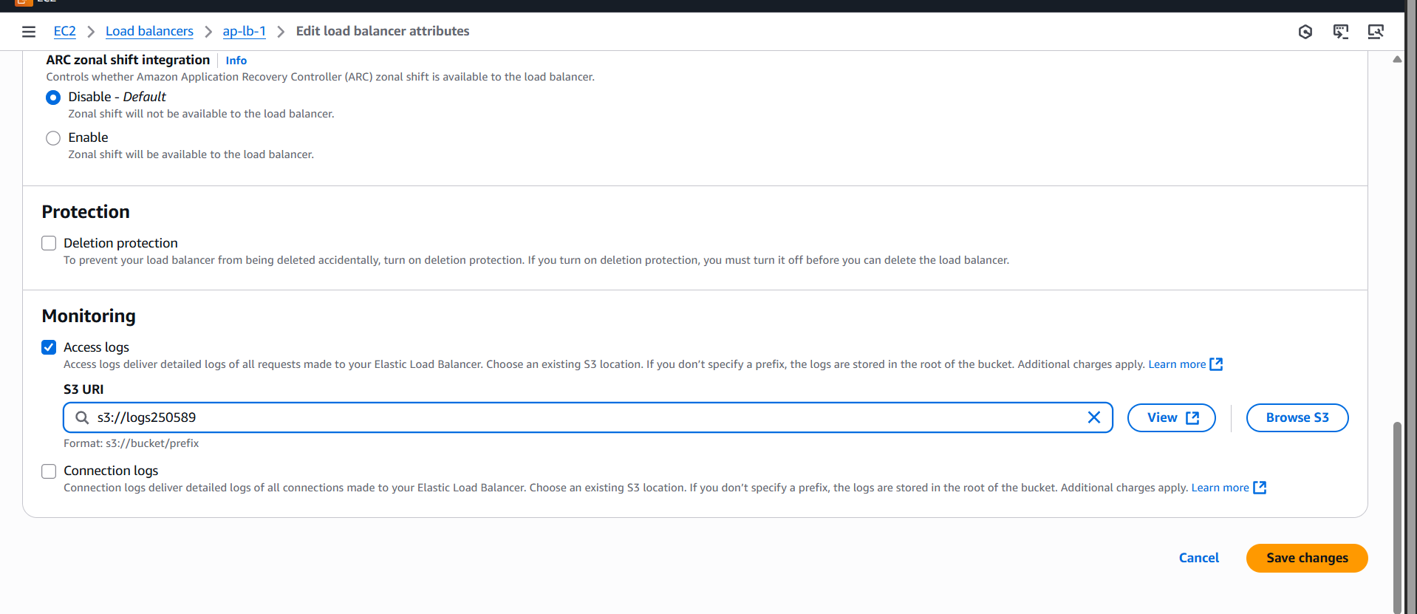
Enable ALB Access Logs
Console Method:
- Go to EC2 → Load Balancers → Select your ALB
- Go to Attributes tab → Edit attributes
- Enable access logs → Check the box
- S3 bucket → select your bucket (or type bucket name)
- Prefix (optional) → e.g., alb-logs/ (helps organize logs by folder)
- Click Save changes

